**Task Objectives:** To come up with detailed understanding and complete plan to execute all the codes shared with you already and replicate those codes at my end. Gaining understanding of accessing WRDS though SSH client and dealing/working with datasets.

To work on the TAQ datasets we need to setup the software platform and understand the platform how it works. Below are the software applications that needs to be available/installed on your PC to work and run the TAQ codes.

* WINSCP 🡺 It’s a windows based software application used to view the datasets/files present on Linux/Unix server system(WRDS is installed on Linux OS). We can download WINSCP from the link <https://winscp.net/eng/download.php>. Click the download button and after clicking the download button it will ask for regular installation parameters of software and installs the same. After installing WINSCP open it and select New Site in the left side area after that on the right side of window hostname field give **wrds-cloud.wharton.upenn.edu** and port number should be default as 22. And in the user name give your WRDS user name and password in the password field. As shown below:

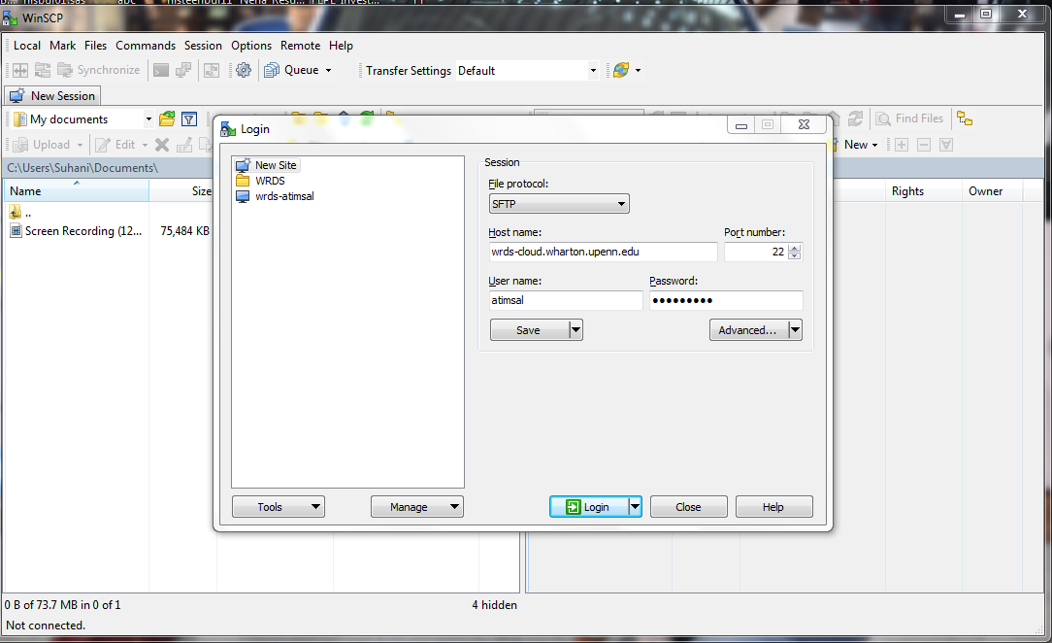

Once you provide details there is an option to save those parameters else you can directly login. Once you click login it will show as below:

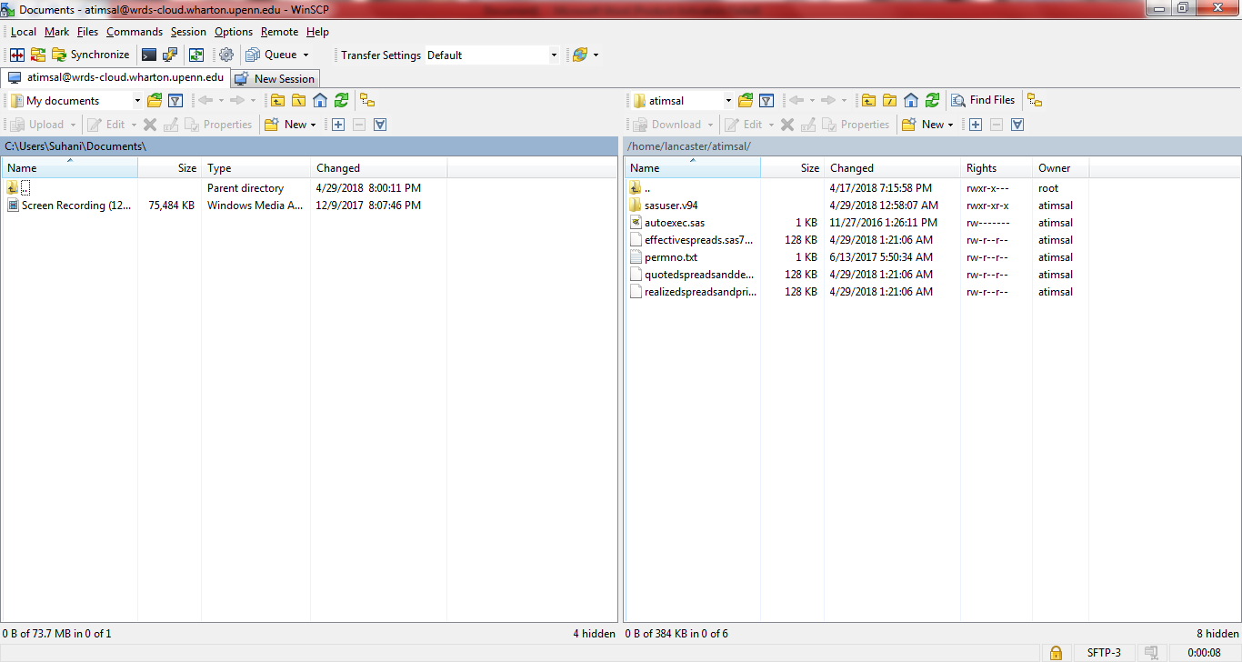

So in the above image window left side area is your local PC and right side window is the WRDS system and it will directly land into the home directory so in this case its **/home/lancaster/atimsal**. So this will also provide you access so that you can directly move files from your local PC to WRDS Linux system vice-versa. This can be done directly by dragging from left side of the pane to right side or from right side to left side(For copying files from WRDS server to local PC). If you want to view the files from TAQ database you need to open the directory by clicking on the icon below in the tool.

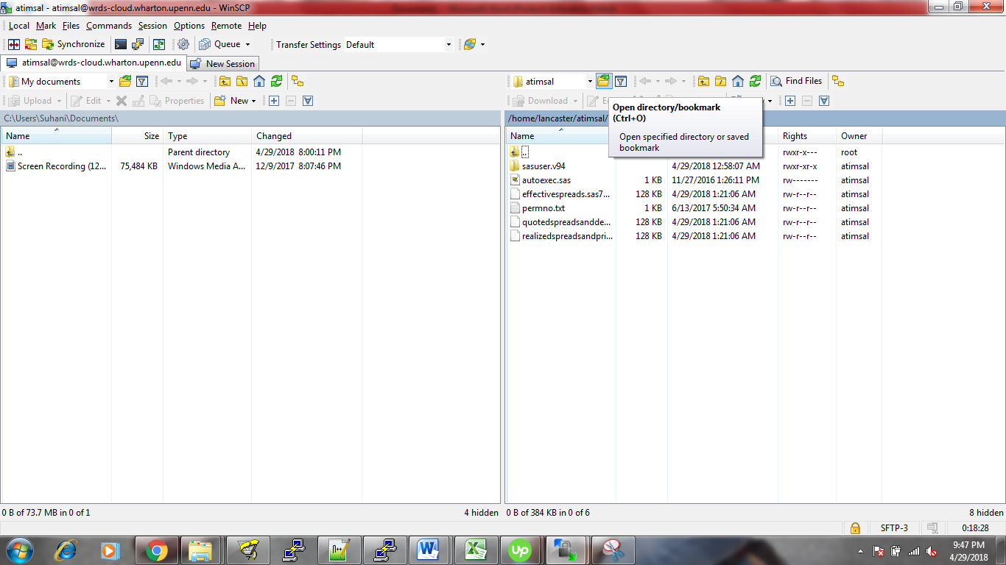 After clicking on the icon as shown above you can type the directory as /wrdslin/nyse/sasdata/taqms/nbbo and click OK to view the nbbo files.( Not recommended though as it takes lot of time for me to view the files as there are a lot and of big size). In this way you can always naviagte to other directory and view the files.

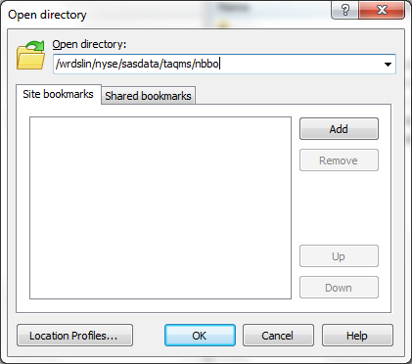

* Putty 🡺 It is used for logging into the WRDS server in a secured way. You can download putty from <https://www.chiark.greenend.org.uk/~sgtatham/putty/latest.html> from the site select software as per your system config depending on either 32-bit or 64-bit.

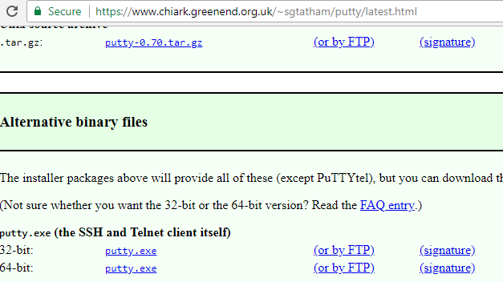

After downloading the .exe file for putty directly open the application and give host name as below

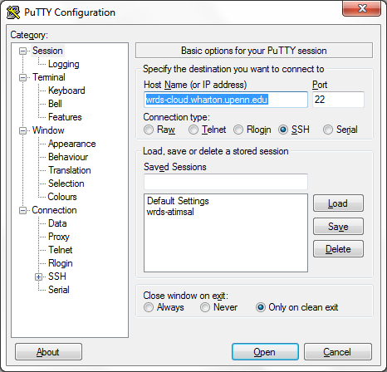

The click OK. So once in your in it will prompt for user name (Login as : ) and Password. You need to provide the WRDS credentials here. I don’t recommend using putty for you as you already have PC SAS installed so all the programs needs to be run from local PC SAS instead of putty. The reason to install putty is to check if you can open any TAQ database files using VIM editor so that it will determine if you access or not. For example if you want to know if you have access to a file named **nbbom_20121231.sas7bdat**. In putty you need to navigate to location **/wrdslin/nyse/sasdata/taqms/nbbo** using command as below

**cd /wrdslin/nyse/sasdata/taqms/nbbo** then after thattype command

**vim nbbom_20121231.sas7bdat** so if you don’t have access it will show as permission denied at the bottom of the screen as shown below.

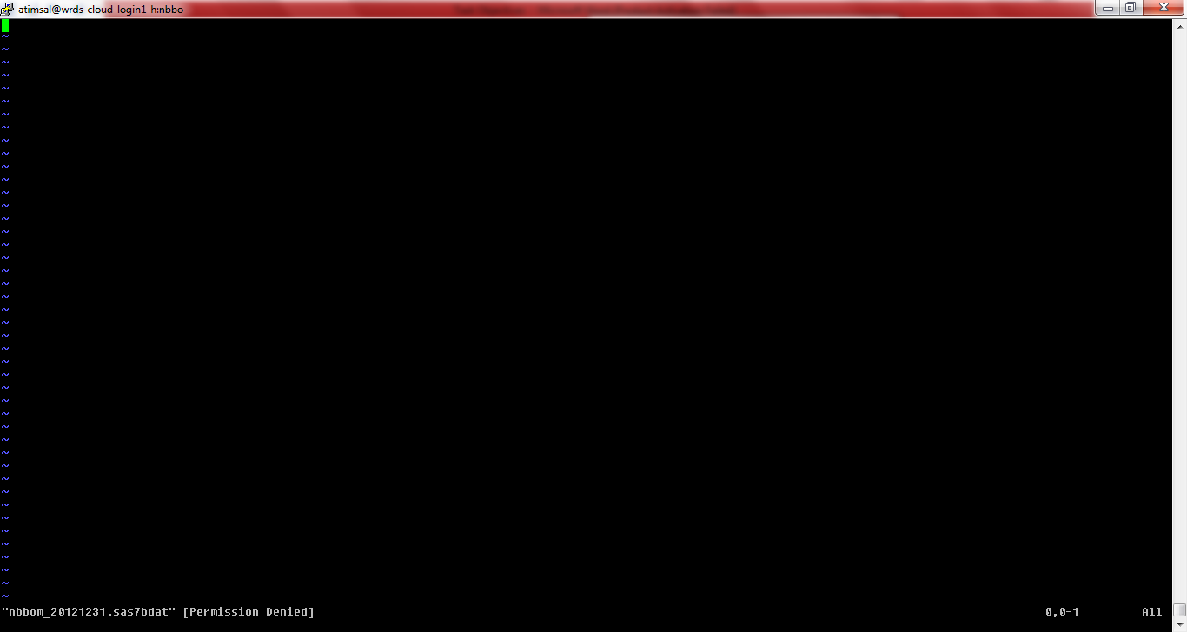

If you have access to that file it will open that file and show the content. If you want to come out of VIM editor you need press **ESC** key and type **:q!** and press **ENTER** key. To navigate to other directories in Putty you need to have knowledge on Linux commands.